https://prcrackerspadalur.blogspot.com/2023/10/pr-crackers.html

[PR crackers](https://prcrackerspadalur.blogspot.com/?m=1)

**PR Crackers **

[October 10, 2023](https://prcrackerspadalur.blogspot.com/2023/10/pr-crackers.html?m=1)

Sure, I can help you with information about a crackers shop. A crackers shop is a retail store that sells a variety of crackers. These crackers can be of different types, including:

Snack Crackers: These are popular for their crispy and salty taste and come in various ﬂavors like cheese, peanut butter, and more.

Firecrackers: Firecrackers are small explosive devices that produce a loud noise and colorful sparks when ignited. They are often used in celebrations, especially during holidays like New Year's and Diwali.

Party Crackers: These are festive items that contain small toys, trinkets, or paper crowns and are often used in celebrations and parties.

Saltine Crackers: These are plain, salty, and crispy crackers that are often used as a base for toppings like cheese or spreads.

If you are looking for a speciﬁc type of crackers shop in your area or need more information about crackers, please provide more details or ask any speciﬁc questions you have in mind, and I'll be happy to assist further.

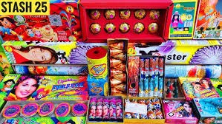

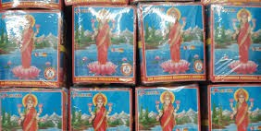



[#prcrackers #no 1 crackers #traditional crackers #good crackers # affordable Crackers](https://prcrackerspadalur.blogspot.com/search/label/%23prcrackers %23no 1 crackers %23traditional crackers %23good crackers %23 affordable Crackers?m=1)

To leave a comment, click the button below to sign in with Blogger.

SIGN IN WITH BLOGGER

[Powered by Blogger](https://www.blogger.com/)

Theme images by [Michael Elkan](http://www.offset.com/photos/394244)



**[PR CRACKERS](https://www.blogger.com/profile/04853606634140079996)**

[VISIT PROFILE](https://www.blogger.com/profile/04853606634140079996)

**Archive Labels** [Report Abuse](https://www.blogger.com/go/report-abuse)